1. Physics about tethers.

By using electrodynamic drag to greatly increase the orbital decay rate of a spacecraft, a Terminator Tether system can remove unwanted objects from LEO rapidly and safely. This technology uses a passive interaction with the Earth’s magnetic field to generate drag, so no propellant or input power is required. Consequently, the Terminator Tether can deorbit even defunct spacecraft.

1. Dynamics of motion

Drag force on tether-

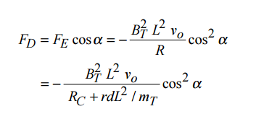

Area time product-

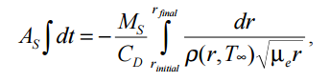

where AS is the cross sectional area of the spacecraft, r is the average semimajor axis of the orbit, CD is the coefficient of drag, and ρ(r,T∞ ) is the atmospheric density as a function of the semimajor axis and the slowly-varying exospheric temperature, T∞

1. Emission methods
2. Thermionic emission

Once the electrons are thermionically emitted from the TC surface they require an acceleration potential to cross a gap, or in this case, the plasma sheath.

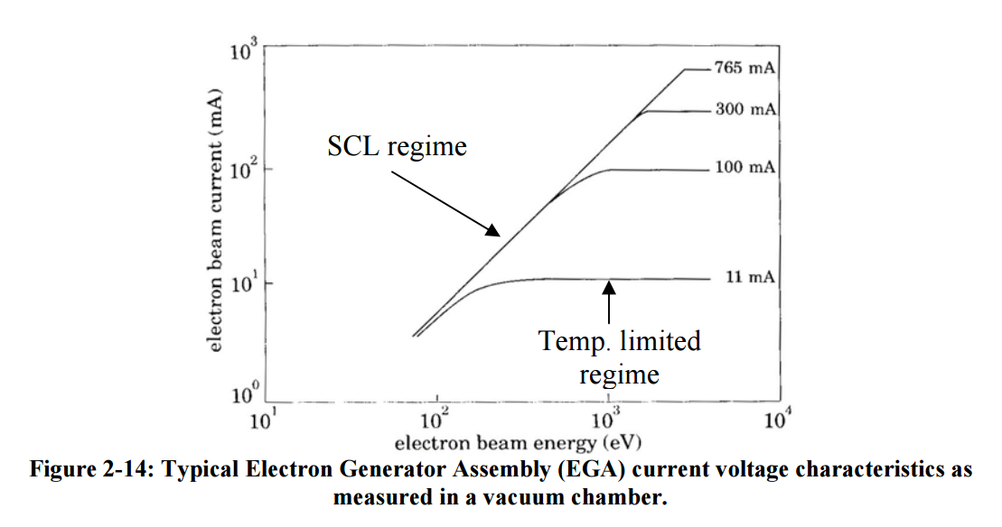

1. FEA

The advantages of field emission technologies over alternative electron emission methods are: 1) No requirement for a consumable (gas) and no resulting safety considerations for handling a pressurized vessel 2) A low-power capability 3) Having moderate power impacts due to space-charge limits in the emission of the electrons in to the surrounding plasma.

One major issue to consider for field emitters is the effect of contamination.

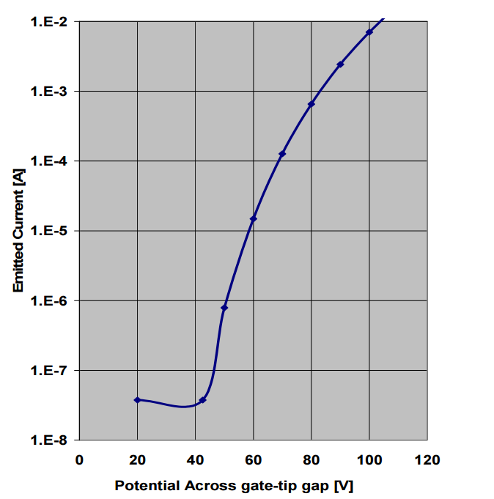

1. Hollow Cathode-

Hollow cathodes emits a dense cloud of plasma by first ionizing a gas. This creates a high density plasma plume which makes contact with the surrounding plasma. A noble gas flows into the insert region of the HC and is partially ionized by the emitted electrons that are accelerated by an electric field near the orifice17. Many of the ionized xenon atoms are accelerated into the walls where their energy maintains the thermionic emission temperature. The ionized xenon also exits out of the orifice. Electrons are accelerated from the insert region, through the orifice to the keeper, which is always at a more positive bias.

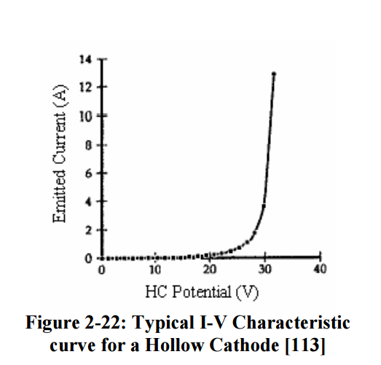

1. Material specification

S p e c i f i c C o n d u c t i v i t y P a r a m e t e r : The choice of the metal conductor to be used in a space tether is determined by a combination of low resistivity (high conductivity) and low density, with cost, strength, and melting point as secondary considerations for certain applications. Copper has a resistivity r=17.0 nΩ-m, a density d=8933 kg/m3 , and a "specific conductivity" of 1/rd=6,585 m2 /Ω-kg. Aluminum has a resistivity r=27.4 nΩ-m, which is significantly greater than that of copper, but it has a much lower density of d=2700 kg/m3 . As a result, aluminum’s “specific conductivity” of 1/rd=13,500 m2 /Ω-kg is twice the conductivity per unit mass of copper. Silver, because of its higher density and higher cost, is not competitive as an electrodynamic space tether even though its resistivity of 16.1 nΩ-m is slightly less than that of copper. An alternate candidate material would be beryllium, with a resistivity r=32.5 nΩ-m, density d=1850 kg/m3 , and a specific conductivity of 1/rd=16,630 m2 /Ωkg, slightly better than that of the much cheaper aluminum. Beryllium also has a higher melting point at 1551 K than aluminum at 933 K, so some of its alloys may be a preferred material for some electrodynamic applications despite its higher materials cost. Unfortunately, despite decades of metallurgical research by the nuclear power industry, highly ductile alloys of beryllium have not been found,

1. Terminator tape

It is a module attached to a spacecraft surface. When the spacecraft has completed its mission, the spacecraft can deploy **10** to several hundred meters length of conducting tape from the module. This tape will induce both increased aerodynamic drag and passive electrodynamic drag, hastening the orbital decay of the spacecraft.